MSP Carbon Assessment [Form A]

Please answer these questions as carefully and completely as you can. If you are not sure of the answer, write about any ideas that you have. If you can help us to understand how you think about these questions, then we can do a better job of explaining science in ways that make sense to you.

Please put your initials (not your full name) in the boxes
First | Middle | Last

Date __________________________

Class __________________________ Teacher __________________________

- A small oak tree was planted in a meadow. After 20 years, it has grown into a big tree, weighing 500 kg more than when it was planted.
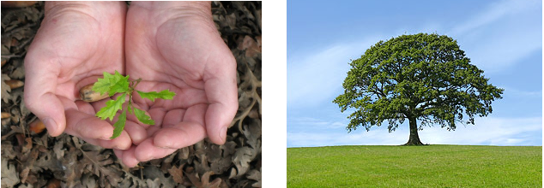

Do you think the tree needs any of the following things to grow and gain weight? Choose either YES or NO and explain your choice.
Things | Does the tree need it to grow bigger? | If you chose YES, explain how the tree uses it. What happens to it inside the tree?
Sunlight | ◻ YES ◻ NO | Level 4. Students choose YES for sunlight, water, and air, and choose NO for soil. Explain that weight gain comes from air (carbon dioxide) and water, and energy of sunlight is needed for photosynthesis, but it does not change into matter of the tree.
Soil | ◻ YES ◻ NO | Level 3. Students explain weight gain in terms of photosynthesis, but also state that light energy changes into the matter of the tree.
Water | ◻ YES ◻ NO | Level 2. Students explain weight gain in terms of “material transmutation”—water, soil, sunlight, and air are mixed together to make food, or any other hidden processes. Students do not conserve mass.
Air | ◻ YES ◻ NO | Level 1. Students explain weight gain as the result of size change or the tree naturally creating materials inside. They may also explain: The tree has needs; when the needs are satisfied, they grow.
- Which of the following is (are) the energy source(s) for plants? Choose either YES or NO for each of the following.

- Water  - Sunlight  - Air  - Nutrients in soil  - Plants make their own energy. | ◻ YES ◻ NO  ◻ YES ◻ NO  ◻ YES ◻ NO  ◻ YES ◻ NO  ◻ YES ◻ NO

Explain ALL your answers, including why the things you have chosen NO for are NOT sources of energy for plants.
Level 4 students identify sunlight as the only energy source for plants and the explanation is about energy transformation.
Level 3 students identify sunlight as one of many energy sources and explanation is about matter-energy conversion or identify some reactants and products of photosynthesis.
Level 2 students describe the process of “making food” and food is energy for plants to grow.
Level 1 students do not explain in terms of either matter or energy. Instead, they explain that plant have “needs” such as water, sunlight, air, soil, etc.

- What happens to energy from the sun after it enters a plant and goes through photosynthesis? Choose either YES or NO for each of the following.

The energy…
- will not exist because it is used up in the process. | ◻ YES ◻ NO
- will leave the plant’s body as energy | ◻ YES ◻ NO (part of the energy leaves the plant’s body as heat. However, we don’t require students to know about heat dissipation in photosynthesis. So, either Yes or No are good.)
- will change into a material or materials during photosynthesis and be stored in the plant’s body. | ◻ YES ◻ NO
- will change into another form of energy during photosynthesis and be stored in the plant’s body. | ◻ YES ◻ NO

If you think none of the above is true, provide your own answer:
The energy…
__________________________________________________________________________________________________________________________________________________

Explain why you chose either YES or NO for each option. In your explanation, you could include additional information such as the name of material or the form of energy.
Level 4. Students choose Yes for d, No for a and c. They explain that light energy becomes chemical energy stored in the plant’s body tissues.
Level 3. Students may choose Yes for b, c, or d. They also choose No for a. They may explain that energy becomes matter.
Level 2. Students explain that energy powers processes such as cell multiplication, making food, etc.
Level 1. Students explain that energy is used up. Or explain energy as a condition for plant to grow.

- To study the effect of light on plant growth, Kaitlin set up an experiment as follows. She placed a plant in a transparent glass chamber under the light source (Chamber A) and another plant in a chamber covered with cloth to block light from the outside (Chamber B). Then she installed an oxygen (O₂) probe and a carbon dioxide (CO₂) probe in each chamber to measure the amount of the two gases over time. Answer the following questions.

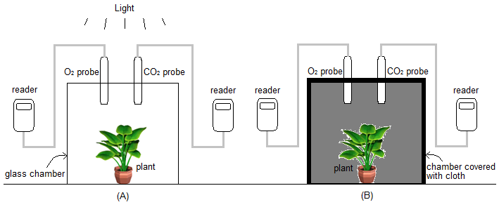

  - What do you predict will happen to the amount of oxygen (O₂) and carbon dioxide (CO₂) in each chamber? (Choose one of the three options for each sentence below.)

 | (A) | (B)
The amount of oxygen (O₂) will… | ◻ increase.  ◻ be the same.  ◻ decrease. | ◻ increase.  ◻ be the same.  ◻ decrease.
The amount of carbon dioxide (CO₂) will… | ◻ increase.  ◻ be the same.  ◻ decrease. | ◻ increase.  ◻ be the same.  ◻ decrease.

The mass (how much the plant weighs) of the plant (not including water) will… | ◻ increase.  ◻ be the same.  ◻ decrease. | ◻ increase.  ◻ be the same.  ◻ decrease.

  - Explain your choice. What do you think each plant is doing with oxygen (O₂) and carbon dioxide (CO₂) in each chamber?
(A) | (B)
(This item continues on the next page.)
  - Do you think that the changes in oxygen (O₂) and carbon dioxide (CO₂) in each chamber are connected to changes in the plant’s mass? ◻ YES ◻ NO

Explain your thinking about this.
Level 4. Students choose the correct choices (as indicated above). Explanation: A. The plant gains mass through photosynthesis in which carbon dioxide and water react and produce biomass of the plant and oxygen (Cellular respiration also happens. However, this is not required.) B: The plant only conduct cellular respiration, in which the organic matter of the plant’s body reacts with oxygen and produce carbon dioxide and water.
Level 3. Students may explain the changes of materials in terms of photosynthesis and/or cellular respiration, but they usually cannot correctly trace matter.
Level 2. Students explain the changes of materials in terms of hidden processes such as plant making food (A), consuming body mass (B), and breathing. They cannot connect changes of solids/liquids with gas exchange.
Level 1. Students explain the changes of materials in terms of needs. Plants do not have its needs such as sunlight and air, so they will die.

- The graph below shows carbon dioxide concentrations in the atmosphere in parts per million (ppm) from 1958 until the present.

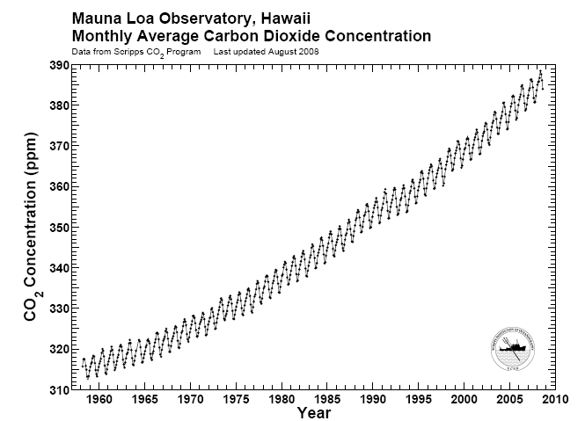

  - Is there anything worrisome about increasing levels of carbon dioxide in the atmosphere? Choose one. ◻ YES ◻ NO
  - If you chose YES, explain why you think higher carbon dioxide levels are worrisome. If you chose NO, explain why you would not be worried.
Note that this item is about citizenship rather than how carbon transforms. Correct explanation is: sunlight hits the ground and is reflected. Carbon dioxide, a type of greenhouse gas, can trap the energy and keep it in the atmosphere, which causes temperature increase. This is how carbon dioxide causes global warming.

- Please use the diagram below to answer the following questions:
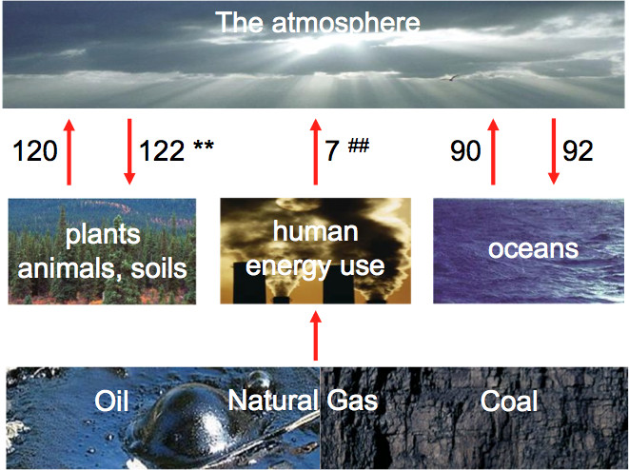
This diagram shows how carbon moved on Earth over the last year. The boxes show places where carbon was located, and the arrows show how carbon moved from one place to another. The numbers show how much carbon moved in gigatons per year. (1 gigaton = 1,000,000,000 tons)
a) Can you tell from this diagram which of the locations listed contains more carbon than others?
◻ YES ◻ NO If YES, how can you tell? If NO, why can’t you tell?

The amount of carbon contained in each reservoir is not listed in the graph.

b) Can you tell from this diagram whether the amount of carbon in the atmosphere is changing?
◻ YES ◻ NO If YES, how can you tell? If NO, why can’t you tell?

Yes. The arrows indicate the amount of carbon moving out of or into each reservoir.

c) How is the carbon in plants and animals different from carbon in the atmosphere?
Carbon in the atmosphere is in carbon dioxide, which does not contain energy. Carbon in plants and animals are in organic compounds such as glucose and lipids. These organic compounds contain C-C and C-H bonds and therefore contain energy.

a, b, and c:
Level 4. Students identify change of carbon in each reservoir by calculating the numbers of the arrows. Students also distinguish between inorganic carbon (CO2) and organic carbon (carbon in organic compounds) stored in the body tissues of plants and animals in terms of energy.
Level 3. Students may or may not be able to figure out the change of carbon in reservoir. They do not distinguish between organic and inorganic carbon in terms of energy. They are able to identify carbon in atmosphere is in Carbon dioxide. They may also able to name some organic compounds in plants and animals.
Level 2. Students are not able to figure out the change of carbon in reservoir. They do not know how carbon in atmosphere is different from carbon in plants and animals.
No Level 1.

d) Which biological process is responsible for moving carbon in the arrow marked with **?

Is the ** - marked process one that humans can change substantially? ◻ YES ◻ NO
If YES, how can we change it? If NO, are there any arrows that we can change substantially?

Photosynthesis. Humans can change this process substantially through farming and deforestation. These activities will remove trees and therefore decrease photosynthesis, a process that remove carbon dioxide from the atmosphere.

Level 4. Identify photosynthesis and the human activities that affect photosynthesis.
Level 3. Identify photosynthesis, but cannot identify relevant human activities that cause the decrease of photosynthesis.
Level 2. Do not identify photosynthesis.
e) Which chemical process is responsible for moving carbon in the arrow marked with ##?

Is the ## - marked process one that humans can change substantially? ◻ YES ◻ NO

If YES, how can we change it? If NO, why do you think so?
Combustion. Humans can change this process substantially through burning fossil fuels such as cooking, driving cars, and generating electricity.

Level 4. Identify combustion and the human activities that affect combustion.
Level 3. Identify combustion, but cannot identify relevant human activities that cause the decrease of photosynthesis.
Level 2. Do not identify combustion.

Use the table below to explain where you think that carbon is found inside a tree and how it gets there.
Location | Choose either YES or NO | If you chose YES, explain how the carbon gets to that location. Include molecules in your explanation if you can.
Does a tree have carbon in its leaves? | ◻ YES ◻ NO | Level 4 students choose yes for leaves, wood, and roots. They explain that carbon gets to leaves because carbon dioxide reacts with water to produce glucose (and also oxygen) in photosynthesis; and photosynthesis happens in the leaves. They also explain that the organic materials such as glucose are carried to wood and roots from the leaves.  Level 3 students identify carbon in leaves. Their explanation mentions that organic materials are produced and organic materials contain carbon.  Level 2 students do not identify any chemical change. They may explain that plants take in carbon dioxide and that is why plants have carbon. Or state that plant parts contain carbon because of some hidden processes.  Level 1 students may not identify carbon. They may use the word carbon for explanation in ways that do not make sense. They may focus on plant needs.
Does a tree have carbon in its wood? | ◻ YES ◻ NO
Does a tree have carbon in its roots? | ◻ YES ◻ NO

- When a baby was five months old, she weighed 15 lbs. After 7 years, the baby has grown into a girl weighing 50 lbs.
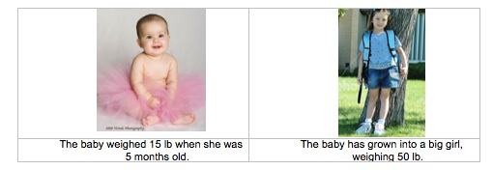

Do you think the baby girl will need any of the following things to gain weight and grow? Please choose either YES or NO and explain your choice.
Things | Does the girl need it to grow? | If you chose YES, explain how the girl’s body uses it. What happens to it inside the girl’s body to help the girl gain weight?
Sunlight | ◻ YES ◻ NO | Level 4. Choose Yes for food and No for sunlight and air. May choose Yes or No for water. Note that because the question is “does the girl need it to grow?” not “where does the weight come from?”, we need to focus on explanation not just choices when scoring the student’s responses.  The student explains that weight gain is from mostly food in digestion and biosynthesis: Food contains organic molecules (polymers), which are broken down during digestion, and then are used by the body to make new polymers, during biosynthesis. The student may also state that water contributes to weight gain. They should not state that sunlight and air contribute to weight gain.
Water | ◻ YES ◻ NO | Level 3. The student explains that weight gain comes from food (and water), but do not successfully explain how organic molecules transform in digestion and biosynthesis.
Air | ◻ YES ◻ NO | Level 2. The student explain weight gain as the result of hidden processes such as gas exchange in breathing, food energy is used up to power cell multiplication, food, air, water, and sunlight are mixed together to produce body mass, etc.
Food | ◻ YES ◻ NO | Level 1. The student explain weight gain as the result that the body gets its needs.

- An apple is eaten by a boy and digested in his body.

  - What happens to the apple when it is digested?

  - Do you think the apple the boy ate can help all parts of his body (like his fingers) to gain weight and grow?

Choose one: ◻ YES ◻ NO
If you chose YES, explain how an apple that goes to the boy’s stomach can help his fingers to gain weight and grow. If you answered NO, please explain how the boy’s body makes his fingers gain weight and grow.

Level 4. The student explains digestion as a process in which organic molecules (polymers) are broken down into simpler molecules (monomers). The student also explain weight gain as a process in which the simpler molecules are transported by blood to cells all over the body and then the simpler molecules are reassembled into more complex organic molecules in cells.

Level 3. The student explains that weight gain comes from food (and water) in chemical reactions, but he/she cannot successfully explain how organic molecules transform in digestion and biosynthesis. They may explain that food becomes energy, which is used up to power cell multiplication and growth.

Level 2. The student explains that food somehow changes into body mass. He/she cannot explain any chemical changes.

Level 1. The student explains weight gain in terms of needs. The boy needs to eat. Eating food enable him to grow. No hidden process is involved in this event.
Look at the picture of a simple carbon cycle below. Using the diagram, decide which of the following are good explanations for why carbon dioxide (CO₂) is increasing in the atmosphere.
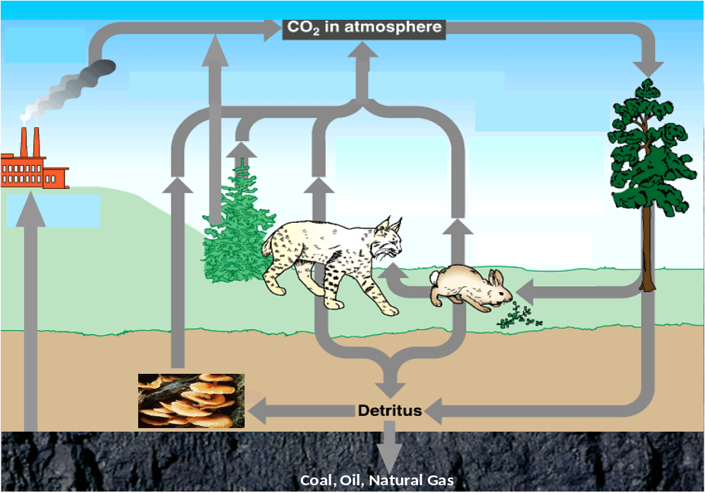
Explanation | Is this a good explanation for why CO₂ is increasing in the atmosphere? | If you answered YES, please say why you think this is a good explanation. If you answered NO, please say why it is not a good explanation.
There are more arrows pointing to the atmosphere than there are pointing away from the atmosphere. | ◻ YES ◻ NO | The diagram does not show the quantities of carbon.
The carbon being taken up by trees does not balance the loss of carbon from humans cutting and burning trees. | ◻ YES ◻ NO | The carbon being taken up by tree is through photosynthesis. The loss of carbon from humans cutting and burning threes is from combustion. There is no causal relation that balance the carbon involved in these two processes.
The carbon being stored through natural processes as fossil fuels (coal, oil and natural gas) cannot balance the carbon being added to the atmosphere from burning these fossil fuels. | ◻ YES ◻ NO | It took millions of years for dead plants and animals turning into fossil fuels in the process of biosynthesis. This process is a long-term and slow natural process. Humans are the energy released from burning fossil fuels for a variety of activities. Combustion (burning) is a quick process. Therefore, the rate we release carbon is much faster than the process of storing carbon in fossil fuels.
There are arrows from humans to the atmosphere that are missing from this picture, such as humans breathing out CO₂. | ◻ YES ◻ NO | Like animals, we release carbon dioxide when we need energy from cellular respiration. In cellular respiration the organic matter in our body reacts with oxygen and produce carbon dioxide and water.

Level 4 responses are elaborated above. The student identify all processes involved including photosynthesis, cellular respiration, and combustion.
Level 3 students identify some but not all processes. They may not successfully trace matter and energy in the processes.
Level 2 students do not identify any carbon-transforming process. They may explain change of carbon in terms of hidden processes such as oxygen-CO2 exchange.
Level 1 students only describe the arrows and other information on the graph. Do not identify any processes (gas cycle or chemical processes) that release carbon into atmosphere or remove carbon from the atmosphere. They may reiterate the sub-statements in the questions without provide any explanation.
- Below are some general questions about climate change. For each question, choose an option that best describes what you think.

  - My current understanding of climate change and global warming is…
    - Excellent
    - Good
    - Average
    - Fair
    - Poor

  - I believe climate change is related to the global carbon cycle.
    - Strongly agree
    - Agree
    - Neutral
    - Disagree
    - Strongly disagree

  - I am optimistic about the future and my ability to have a positive impact on the environment.
    - Strongly agree
    - Agree
    - Neutral
    - Disagree
    - Strongly disagree

  - The environment is irreversibly damaged regardless of my personal actions or the actions of society.
    - Strongly agree
    - Agree
    - Neutral
    - Disagree
    - Strongly disagree

  - I believe the information the media is providing about climate change and global warming to be accurate.
    - Strongly agree
    - Agree
    - Neutral
    - Disagree
    - Strongly disagree

<The End. Thank You.>

